**COMP7940 Cloud Computing**

**Group Project Milestone 3**

1 April 2020

As the COVID-2019 has been declared by the WHO as pandemic, Tencent, as technology giant based in the PRC, started to release the latest data update of the pandemic as the portal site for the first time. We can use crawlers to crawl the data we need. As the epidemic situation has attracted more and more people's attention, the open source API has also been shared. API (Application Programming Interface, application programming interface) is some predefined functions, or refers to the convention of connecting different components of a software system. The purpose is to provide applications and developers with the ability to access a set of routines based on certain software or hardware without having to access the source code or understand the details of the internal working mechanism. We decided to use the COVID-19 data API after studying and comparing. We can use the http.client function to access the url of the API interface through the header. Then port the functionality to the line bot. Enter the name of the country through the dialog box, we can get real-time local epidemic data, including confirmed data, rehabilitation data, death data, etc.



The picture above shows the initial debugging results. (1.Source: https://rapidapi.com/2.tutorial:<https://www.youtube.com/watch?v=ViaBzK11EkE>)

In addition to the above, a query function has been developed to let users locate public hospitals in Hong Kong. A service, Heroku Postgre(1.Source:<https://elements.heroku.com/addons/heroku-postgresql> 2.tutorial:<https://www.youtube.com/watch?v=OvQetdMN88E>) has been added to our Heroku app. When the key words “location of” is input by the user, the database will return the latitude and longitude values of the hospitals to the LINE Messaging API which will then post the location messages of the hospital. The LINE bot also makes use of LINE Flex Message Simulator to return carousel checklists. The following is a screenshot of these functions:

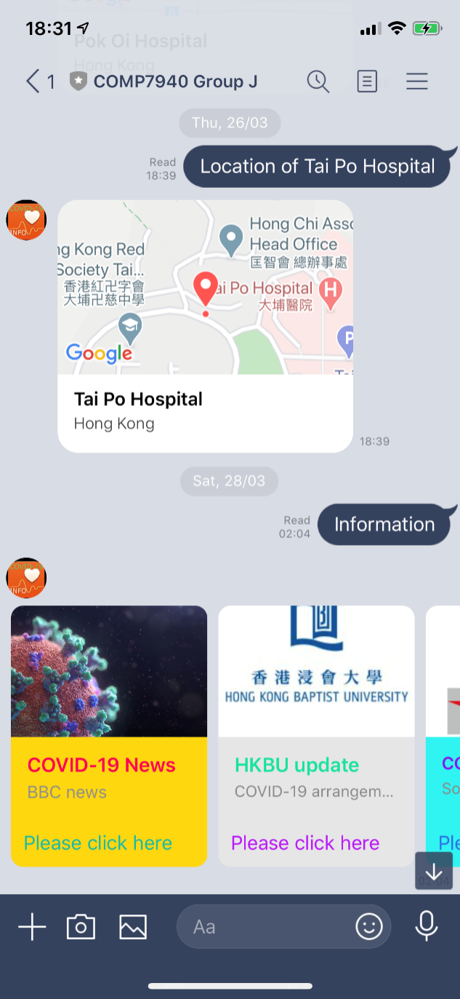

It is also intended to combine Google API into our LINE bot to perform more functions including searching and crawling.

**Group project Group Members**:

Lo Chi Leung (SID: 19451415) (GitHub id: HKBU-DavidLo)

Ye Wei Xiong (SID: 19451407) (GitHub id: handsome168-web)

Zhang Kai (SID: 19404549) (GitHub id: ZHANGSHAO1212)